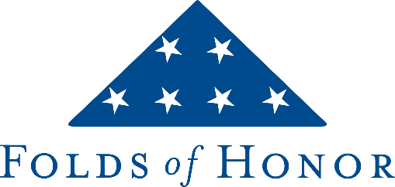

FOR IMMEDIATE RELEASE

[Insert facility/company name] Plays a Golf Marathon Benefiting Folds of Honor
Donations Provide Academic Scholarships to Families of Fallen or Disabled Service Members and First Responders.

[City, State], [fill in date] – On [date of marathon], the [identity of players, ex. Golf Professionals] at [facility/company name] will be teeing it up for the Folds of Honor, a non-profit organization that provides educational scholarships to children and spouses of fallen or disabled American service members and first responders.

Led by [lead marathoner], these Patriots have committed to playing non-stop golf from sun-up to sun-down for scholars who need and deserve the help. In return for their efforts, they are asking their [insert “members” or “company”], the community, friends, and family to pledge money in advance per hole played or with a flat donation. Their goal is to raise a minimum of $[fundraising goal], enough to fund [X] full scholarship.

"We are grateful to the [“golf staff” or company] at [insert golf course name, if applicable] and all those that contribute," said Lt Col Dan Rooney, Founder and CEO of Folds of Honor. "This is truly a community effort of patriots who understand the needs of the military and first responder families we serve and want to help."

The Folds of Honor impact is felt close to home. In the past 15 years, [get info from Folds] scholarships have been provided locally worth about $[get info from Folds]. Since Folds of Honor's inception in 2007, nearly 44,000 scholarships have been awarded for about $200 million in all 50 states. Among the students served, 41 percent are minorities. This academic year alone, more than 9,000 scholarships were dispersed: a 40% increase over the previous year. However, not all qualified recipients were awarded scholarships due to limited funds. The need remains great. Over the last 14 years, golfers nationwide have been instrumental in raising donations for Folds of Honor making their golf activities the largest grassroot golf fundraising in the country.

To learn more about, and support, [insert name of fundraising group], please visit [insert link to fundraising page] or call [insert name of main contact/business/club] at [insert phone number]. For more information about Folds of Honor, please visit www.foldsofhonor.org.

About Folds of Honor
Folds of Honor is a 501(c) (3) nonprofit organization that provides educational scholarships to the spouses and children of military members who have fallen or been disabled while serving in the United States armed forces. Beginning in 2022, it expanded its mission to include first responders. Its educational scholarships support private-school tuition or tutoring in grades K-12 as well as post-secondary tuition. It is rated a four-star charity by Charity Navigator and Platinum on GuideStar. It was founded by Lt Col Dan Rooney, an F-16 fighter pilot, who is currently stationed at Headquarters Air Force Recruiting Service Detachment 1, at Joint Base San Antonio-Randolph, Texas. For more information www.foldsofhonor.org.

# # #

Folds of Honor Contact:
Folds of Honor Golf
golf@foldsofhonor.org

